Copyright for test papers and marking guides remains with *West Australian Test Papers.*

Test papers may only be reproduced within the purchasing school according to the advertised Conditions of Sale.

Test papers should be withdrawn after use and stored securely in the school until Friday 12th June 2020.



**SEMESTER ONE**

**MATHEMATICS**

**METHODS**

**UNIT 3**

**2020**

**SOLUTIONS**

**Calculator−free Solutions**

1. (a) 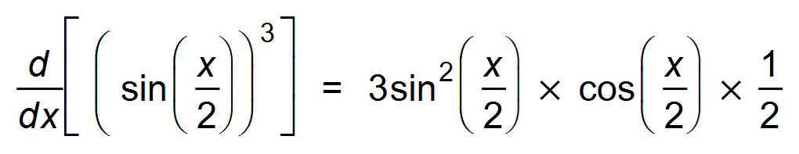 ✓✓

(b) 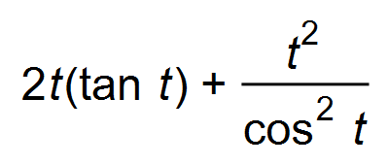 ✓✓

(c) 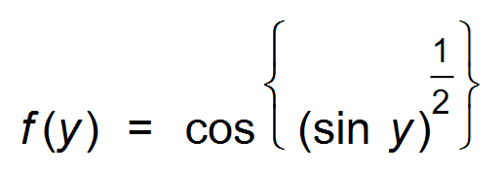

∴ 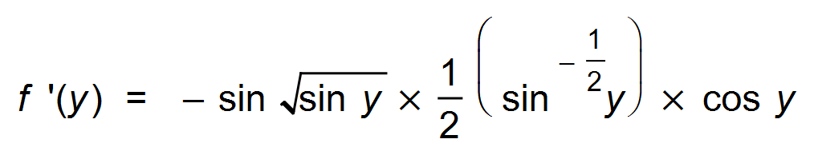 ✓✓✓ [7]

2. (a) 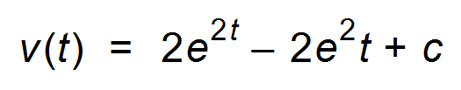 ✓

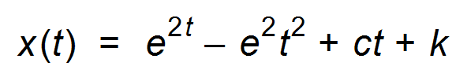 ✓

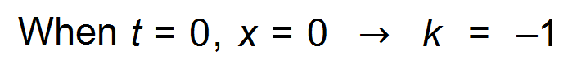 ✓

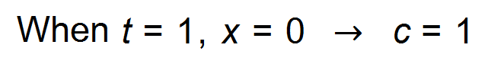 ✓

∴ 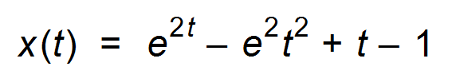

(b) 0 ✓

(c) 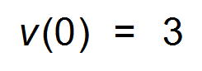 ✓ [6]

3. (a) 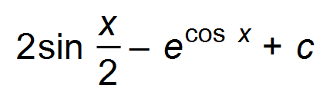 ✓✓

(b) 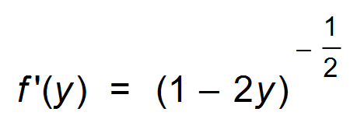

∴ 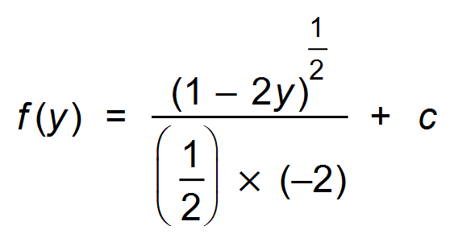 ✓✓

∴ 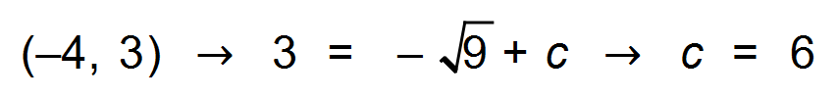 ✓

∴ 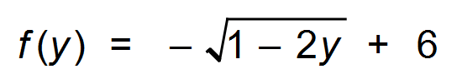 ✓

(c) 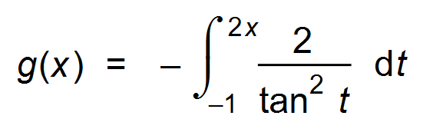 ✓

∴ 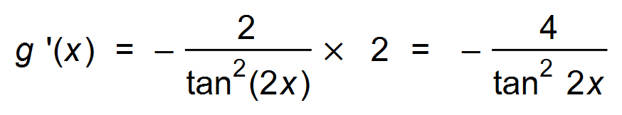 ✓✓ [9]

4. (a) 6 represents 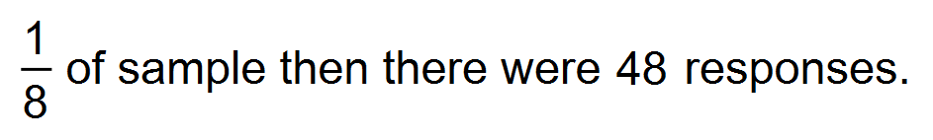 ✓

∴ 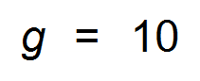 ✓

∴ 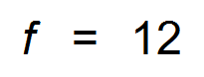 ✓

and 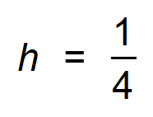 ✓

(b) E(X) = 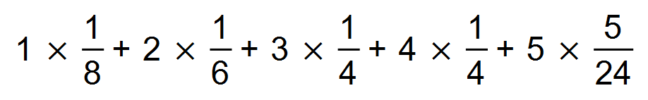 ✓

∴ E(X) = 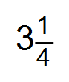 ✓ [6]

5. (a) (i) 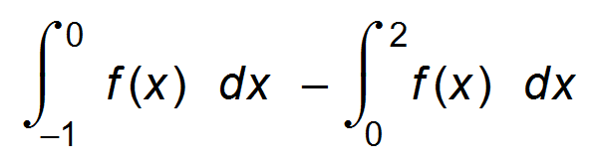 ✓✓

(ii) 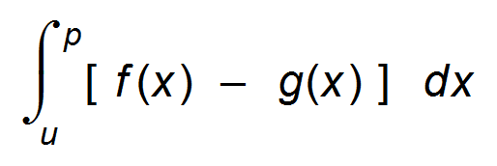 ✓✓

(b) 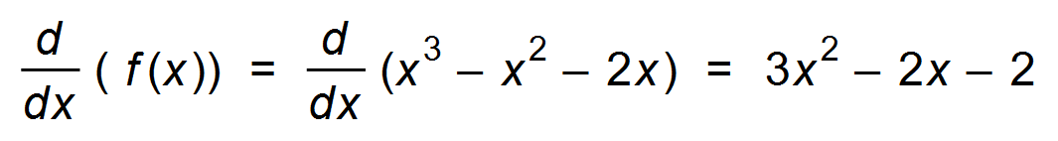 ✓

∴ 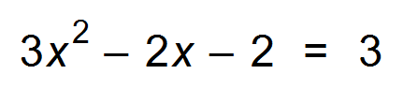 ✓

∴ 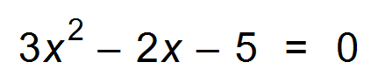

∴ 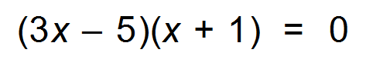 ✓

∴ 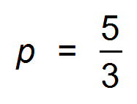 ✓ [8]

6. (a) (i) 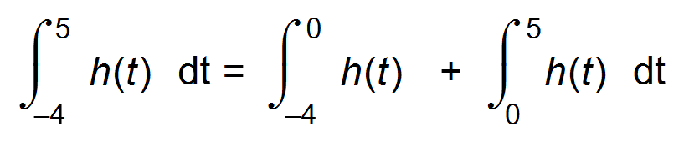

∴ 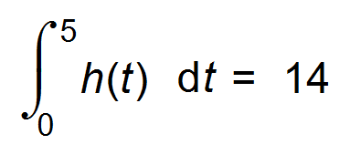 ✓

(ii) 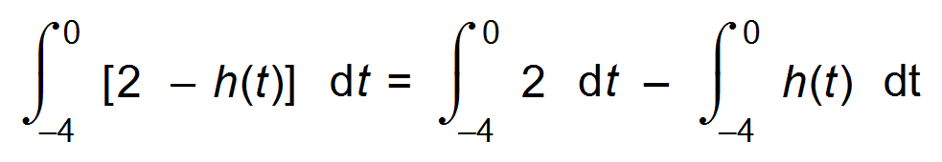

= 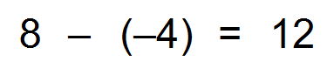 ✓✓

(iii) 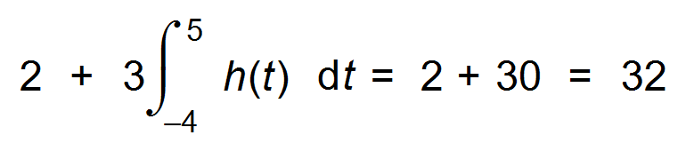 ✓✓

(b) We would need to know where *h*(*t*) lies below the x−axis. ✓ [6]

7. (0, 2) → e = 2 ✓

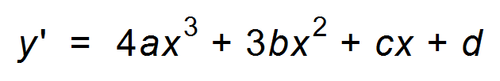 ✓

∴ 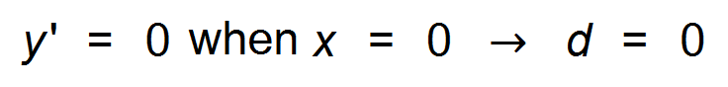 ✓

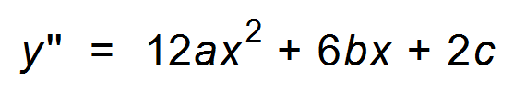 ✓

∴ 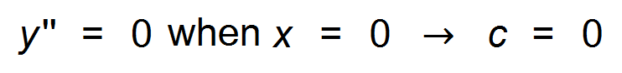 ✓

and  ✓

 ✓

Hence 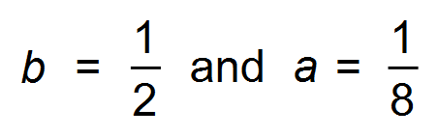 ✓ [8]

**Calculator−Assumed Solutions**

8. (a) *a* + *b* = 26 ✓

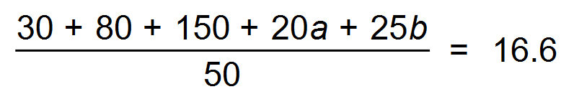 ✓

∴ ***a*** = 16 and ***b*** = 10 ✓✓

(b) Standard deviation = 6.44 ✓✓

(c) (i) 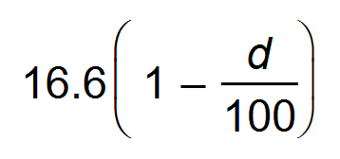 ✓

(ii) 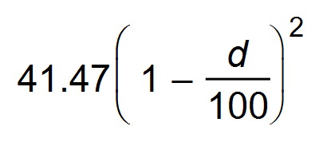 ✓ ✓ [9]

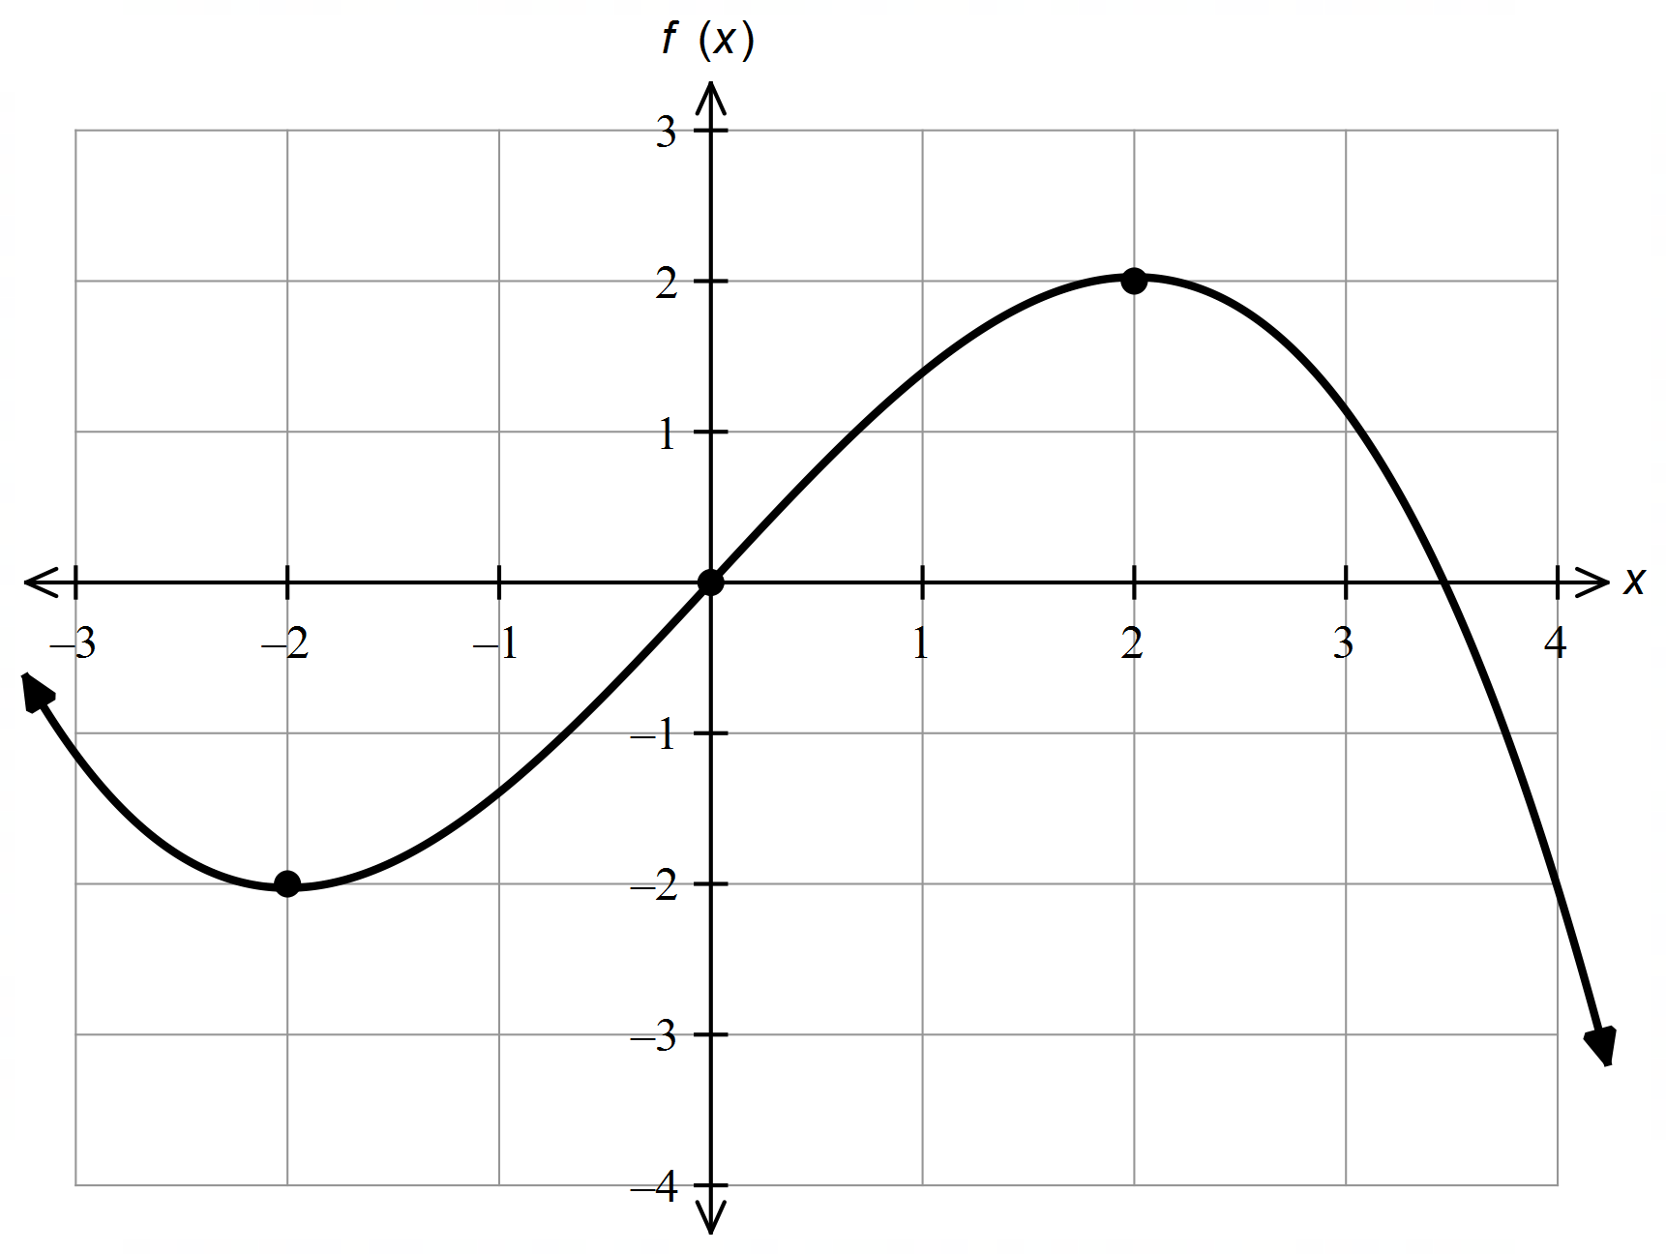9. (a)

✓✓✓✓

(b) (i) 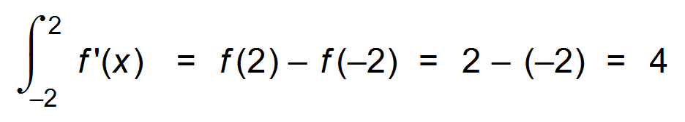 ✓✓

(ii) 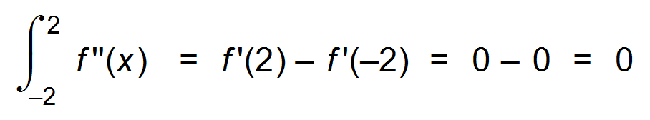 ✓✓

(c) 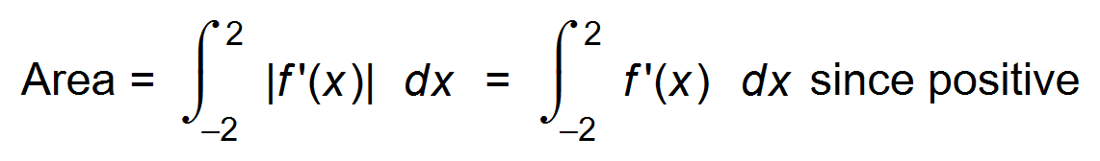 ✓

= 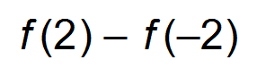

= 4 ✓ [10]

10. (a) 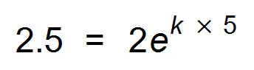  ✓

∴ 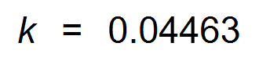 ✓

∴ 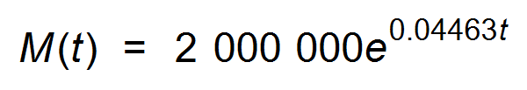 ✓

(b) 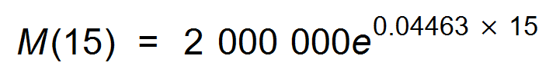 ✓

= 3 906 325 = 3 906 500 ✓

(c) 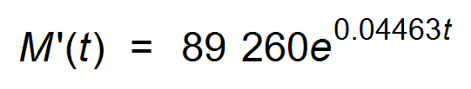 ✓

∴ 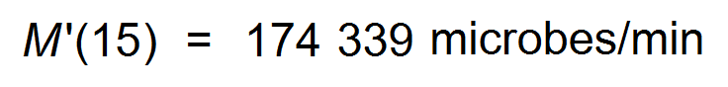 ✓

(d) 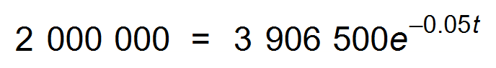 ✓

∴ *t* = 13.39 min ✓

∴ 12:58 pm ✓ [10]

11. (a) (i) 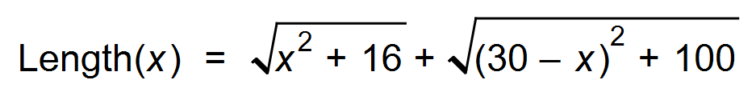 ✓

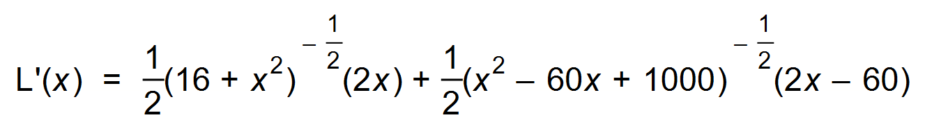 ✓

∴ 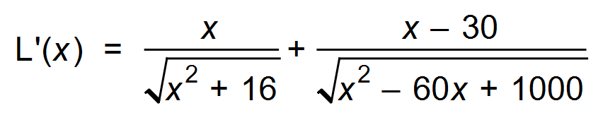 ✓



∴ Min occurs when L′(*x*) = 0 ✓

∴ 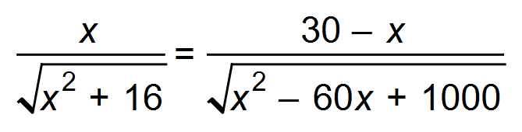

(ii) 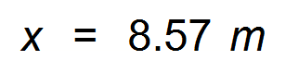 ✓

(b) 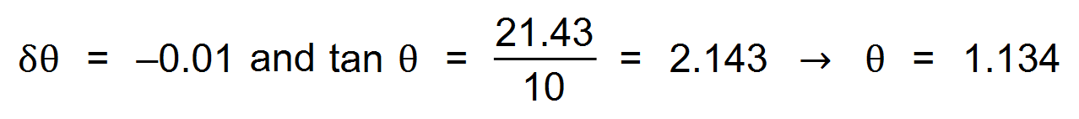 ✓

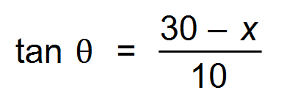 ✓

∴ 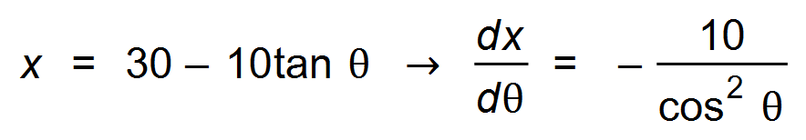 ✓

∴ 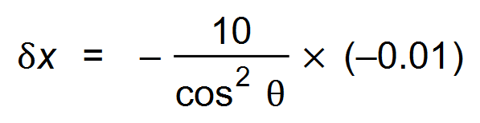 ✓

∴ When 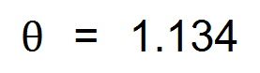 , 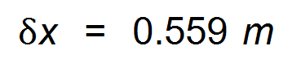 ✓ [10]

12. (a) (i) *x* < −2 or 1 < *x* < 2 ✓✓

(ii) *x* = −2, 1, 2 ✓✓

(iii) *x* < −1.4 or *x* > 1.6 ✓✓

(b) *x* = −1.4 or *x* = 1.6 ✓✓ [8]

13. (a) 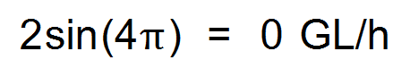 ✓

(b) 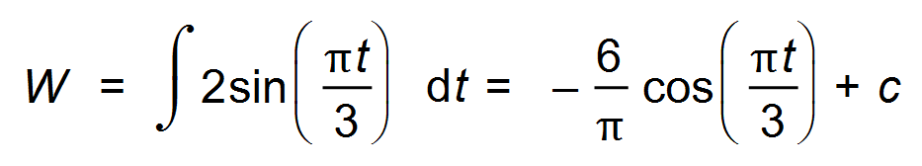 ✓

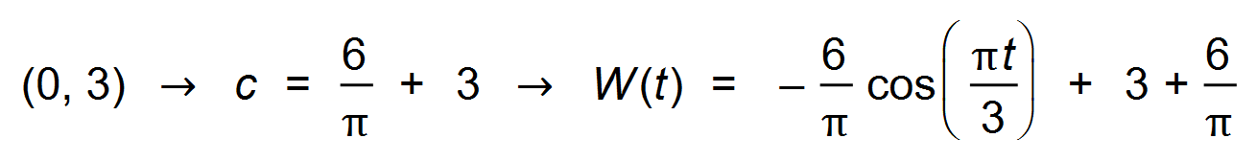✓

∴ At midday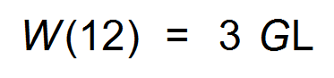 ✓

(c) 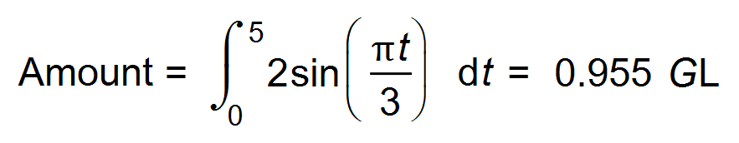 ✓✓

(d) 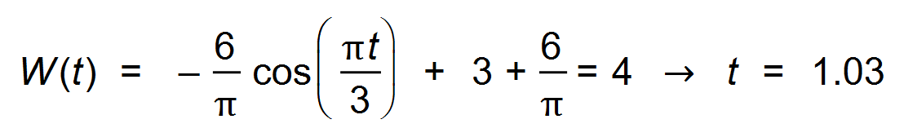 ✓

∴ 1:02 am ✓ [8]

14. (a) DRV and involves success or failure ✓

(b) (i) 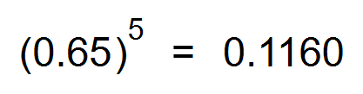 ✓✓

(ii) 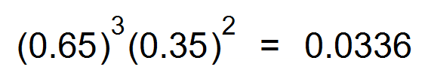 ✓✓

(iii) 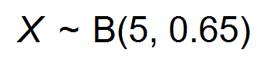

∴ P(X ≥ 2) = 0.9460 ✓✓

(iv) 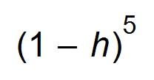 ✓✓

(c) 1 − P(0) = 0.99757

∴ P(0) = 0.00243

∴ 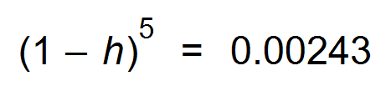 ✓

∴ *h* = 0.7 ✓

(d) VAR = 0.65 x 0.35 = 0.2275 ✓

∴ St dev = 0.4770 ✓ [13]

15. (a) 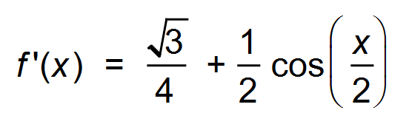 ✓

TP occurs when *f* ′(*x*) = 0

∴ 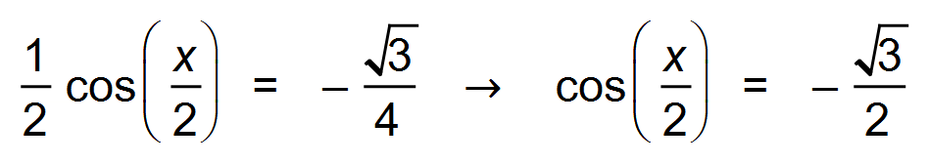 ✓

∴ 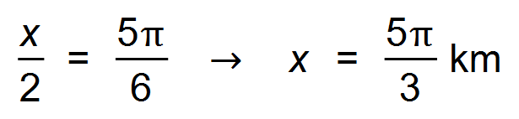 ✓✓

and height = 2.767 m ✓

(b) Max gradient occurs when *f* ′′(*x*) = 0

∴ 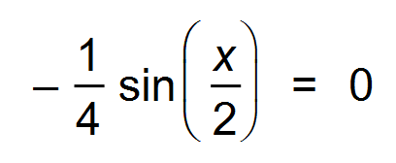 ✓

∴ 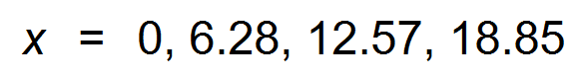 ✓

∴ Max gradient = 0.93 ✓ [8]

16. (a) 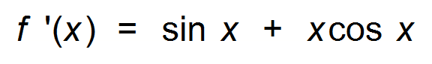 ✓✓

(b) (i) 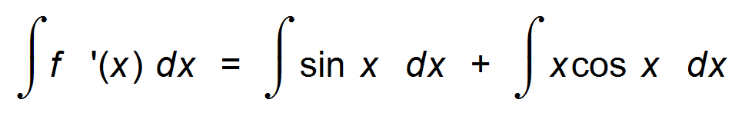 ✓

∴ 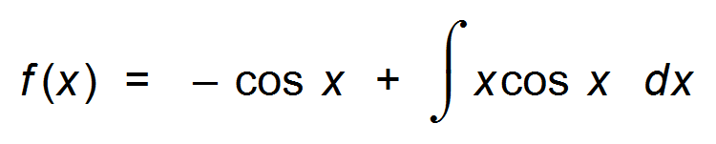 ✓

∴ 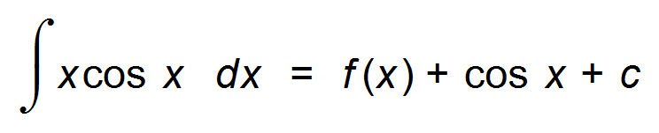 ✓

∴ 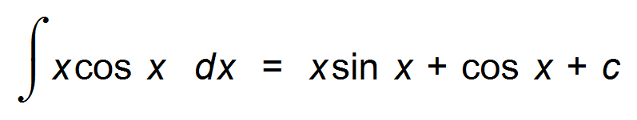

(ii) 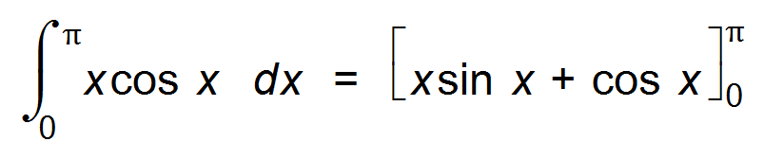 ✓

= (0 − 1) − (0 + 1) = −2 ✓

(c) 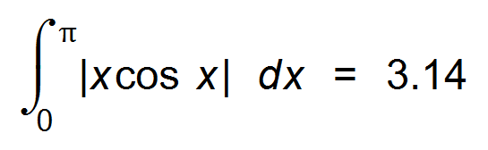 ✓ ✓ [9]

17. (a) Uniform ✓

(b) (i) 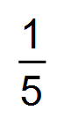 ✓

(ii) 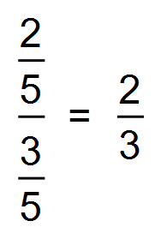 ✓

(iii) 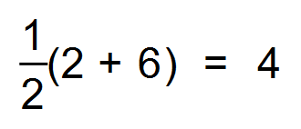 ✓

(iv) 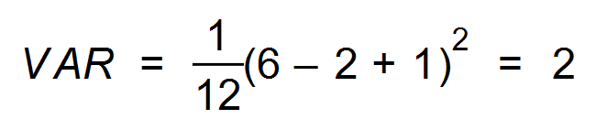 ✓

∴ Std Dev =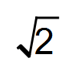 ✓

(c) (i) E(*Y*) = 3 − 2(4) = −5 ✓

(ii) Std Dev(*Y*) = 2(Std Dev(*X*))

∴ = 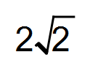 ✓

∴ VAR(Y) =  ✓ [9]

18. (a)  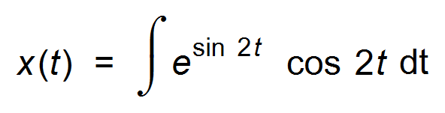

Since 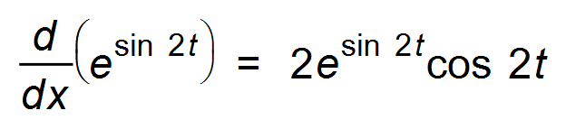

∴ 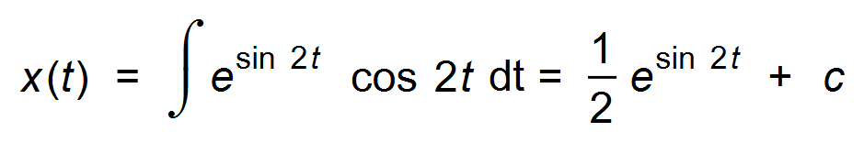 ✓✓

Since x(0) = 0 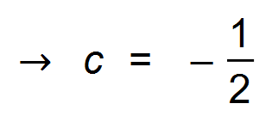

∴ 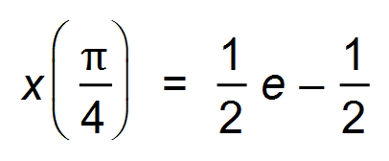 ✓

(b)  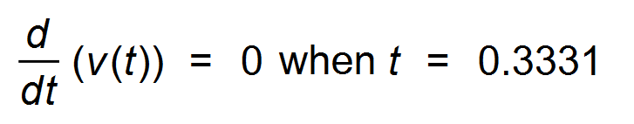  ✓



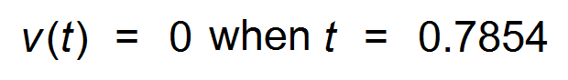

∴ Total distance = 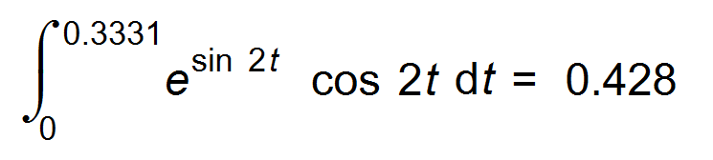 ✓✓ [6]